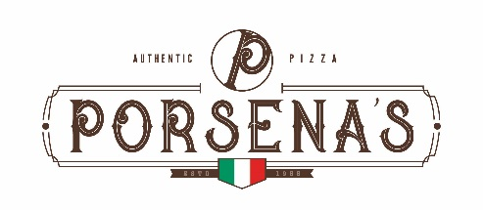

“Get Started” Pizza Oven Program

Buy an oven at a discounted price and get a free case of Porsena’s pizza!! Selling the free case of pizza largely offsets the cost of the oven and better yet, the oven is yours to keep!!

Program Specifics:
When you purchase any 5 cases of Porsena’s Pizzas and a pizza oven for $99 you get one free case of Porsena’s Meat Lovers or Pepperoni pizza. Just request this offer from your Upper Lakes Sales representative and begin to enjoy the best frozen pizza available plus you will own the Wisco 421 Digital pizza oven!

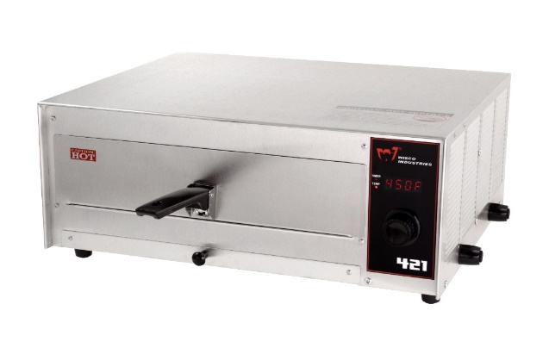

Oven Features:
- LED display
- Adjustable thermostat – 150°F – 500°F in 25° increments
- 30-minute digital display timer
- Quick one-touch setting of 450°F for 10 minutes
- Long life calrod heating elements.
- Removable clean out tray
- Flip up handle design for easier storage
- “Formed” tray to prevent food products from sliding off back of tray

Oven Specifications:
- Dimensions: 18” W x 15” D x 7-3/4” H
- 120 Volts, 12.5 amps, 1500 watts

