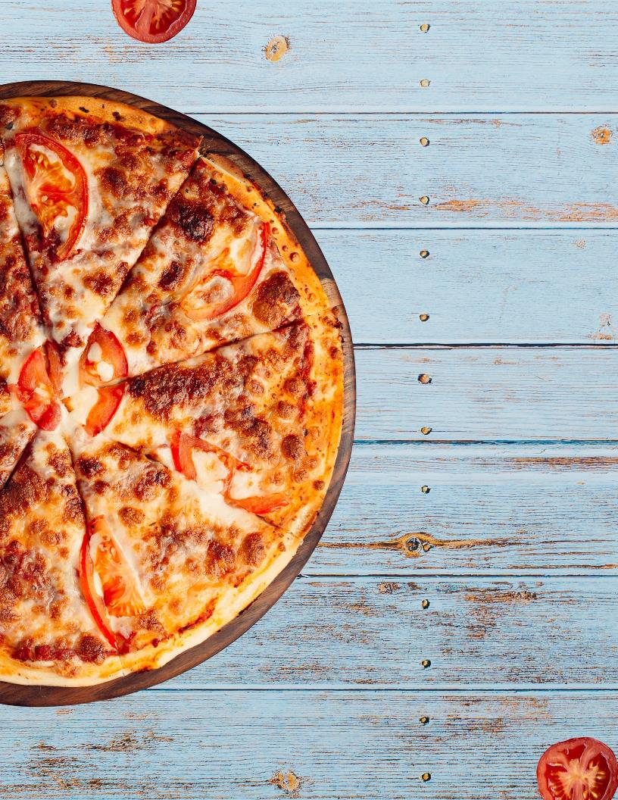
To change image, right click on the top left corner of the pizza image and select “Change Picture” then “From a File.” Insert desired picture from your picture library and adjust. Delete this text box when complete.
 |  | [Business Name]
 |  | NOW OFFERING CURBSIDE PICK-UP!
 |  |  |  | EDIT HEADER
 |  | Caesar Salad  Garden Salad  Spring Salad |  |  | Price  Price  Price |  | Minestrone Soup  Chicken Noodle Soup  Cream of Corn Soup |  | Price  Price  Price
 |  |  |  | EDIT HEADER
 |  | Margherita  Meat Lovers  Pesto Shrimp |  |  | Price  Price  Price |  | Chicken Alfredo  Pepperoni  Hawaiian |  | Price  Price  Price
 |  |  |  | EDIT HEADER
 |  | Baked Ziti  Baked Macaroni  Penne with Tomato |  |  | Price  Price  Price |  | Spaghetti  Shrimp Scampi  Aglio Olio |  | Price  Price  Price
Thank you for your business!

Phone:
Email:
Website:

